
Volunteer Handbook

Table of Contents

House of Hope History 3

House of Hope Mission Statement 4

Volunteer Mission Statement 4

House of Hope Facilities and Programs 5

Volunteer Policies & Procedures 6

Dismissal of Volunteers 6

Tracking of Volunteer Hours Served 10

House of Hope History
HOUSE OF HOPE OF THE PEE DEE
Jean and Bill Fryar saw a shelter in Florence turn away as many as 20 homeless people in 1988 and felt deeply troubled by the lack of a safe haven for them. This became a moment that changed their lives forever. They ignited a mission that opened its doors to the homeless of the Pee Dee in 1990.

MEN’S HOME
In 1991, the original men’s shelter was opened in Effingham, SC, and was called the New Life Rescue Ministry. 2006 – the New Life Rescue Ministry changed its name to House of Hope of the Pee Dee and expanded our offerings to include a women and children’s home for long-term recovery.

COURTNEY MCGINNIS GRAHAM COMMUNITY SHELTER
The 2015 death of a local homeless advocate prompted her family to want to open an emergency shelter to honor her work, and they contacted the House of Hope to see about partnering with us. The Courtney McGinnis Graham Shelter opened in October of 2016. Because the Pee Dee lacked long-term transitional housing for women and children, in 2019, the staff began to dream about tiny houses to meet that need.

HOPE VILLAGE
On September 2020 ground was broken for 24 tiny houses, for dignified, long-term, transitional housing, initially for women and children. And in June of 2022 the first guests were welcomed into HOPE Village.

THE ARC
In June of 2023, the Addictions Recovery Center (ARC) opened, offering men 139 acres for recovery from addictions with an emphasis on growing their relationship with Christ and learning life skills. This addition is the first 90 days in our 12-month Life Recovery Program.

HARTSVILLE COMMUNITY RESOURCE CENTER
In 2025, House of Hope acquired, through anonymous donors, a building in Hartsville that will become a community resource hub. With renovations and lots of support, we hope to open in 2026.

House of Hope Mission Statement

Mission Statement:
House of Hope is a Christ-centered community providing hope by serving the needs of men, women, and children facing homelessness and addiction.

Vision Statement:
Restoring hope and impacting lives through Christ.

Volunteer Mission Statement:
House of Hope of the Pee Dee’s volunteer program exists to connect people who have a desire to share their God-given talents with those in our care by offering personal opportunities that are meaningful to them and beneficial to the ministry.

House of Hope Facilities, Programs & Ministries

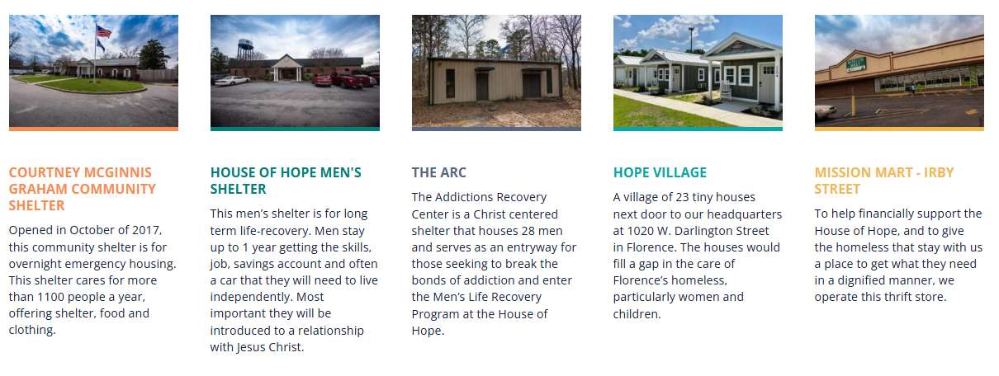

House of Hope of the Pee Dee . . .

- Provides safe, warm shelter and food for over 1,100 homeless and hurting men, women, and children each year at our Courtney McGinnis Graham Community Shelter; even more during cold weather.
- Offers recovery programs for those facing life-dominating addictions, and transitional housing that includes long-term support.
- Operates a thrift store where your donations and purchases help to financially support the ministry.
- Employs trained staff that provide case management, personal and group counseling, daily devotions, and educational opportunities for those in our care.
- Relies on volunteers to provide the necessary manpower to help the ministry accomplish its mission.

Volunteer Policies & Procedures

House of Hope of the Pee Dee recognizes the critical role of its volunteers, and is extremely grateful for the dedication, time, compassion and energy provided to guests across our ministries.
Understanding and abiding by the following policies is critical in treating our guests in a manner that reflects biblical character, shows respect for the value and dignity of all people, recognizes the need for the protection and well-being of all, and is God-honoring.
Violation of one or more of the policies described here on pages 6-10, can result in dismissal from volunteer duties at House of Hope of the Pee Dee.

I. Confidentiality
- Observe, maintain, and protect confidentiality regarding our guests.
- Avoid sharing any information with others that may identify one of our guests.
- Any information shared with you by a child, sibling, roommate, or a staff member (for specific purpose of working with an individual child) must be kept strictly confidential.
- You may not share any personal information about our guests (children or adults) on any social media outlets or with anyone outside of House of Hope of the Pee Dee.
- Refrain from taking pictures of our guests. No pictures or videos may be taken of children in our care at any time. You must have a signed waiver authorizing you to do so with adults.
- Never ask a staff member about the circumstances of a particular child. Our staff is bound by a confidentiality pledge and may not divulge information.
- For the emotional and physical protection of the children in our care, the SC Department of Social Services dictates with whom they may have contact and the frequency of that contact.
- It is not within the scope of a volunteer’s responsibility to help a child make contact with family members or other previous care takers. A volunteer should never agree to mail a letter for a child or promise to make a phone call for them.

II. Appropriate Attire
- Volunteers are asked to maintain modest and respectful dress attire while serving.
- No sweats, spaghetti strap tops, low cut tops, yoga or tight fitting pants, short shorts or skirts, torn clothing, or open-toed shoes (i.e.: flip flops)

III. Authority
- The HOH staff member who is in direct care of our guests is the authority in charge.
- Please direct any questions or concerns you may have about our guests with regard to schedules, behavior, discipline, programs, etc. to the facility staff on duty.

IV. Physical Contact
- Avoid being alone with any guest (child or adult) at any time, unless otherwise specified. If the nature of the volunteer task calls to be alone with
the guest, the volunteer should be in sight of a window, open door, etc.
- Your interaction with any guest (child or adult) is to take place in open common areas. Volunteers are not permitted to be in guests’ bedrooms or bedroom hallways.
- Do not accompany children in our care to the bathroom. Do not change diapers, take a toddler to go “potty,” give a resident a bath or help a child change clothes. The staff on duty will take care of any type of bathroom needs.
- Avoid initiating or asking for any physical contact with adult guests. Many guests have suffered traumatic situations and any physical touch (hugging, holding hands, etc.) can be an emotional trigger. Appropriate physical contact is only permissible when initiated by the guest (examples of appropriate
physical contact are a hug from the side and holding hands during prayer).
- Avoid horseplay or tickling children. Avoid any situation where your intentions could be misinterpreted by a child.
- Do not allow children in our care to sit on your lap.
- Giving a child a hug is permissible with the child’s permission, or initiation, but be very intentional to hug from the side with an arm around the shoulders.

V. Interaction with Guests
- Do not give guests your phone number or home address.
- Refrain from offering medical, legal, or financial advice to any of our guests. Any items of this nature should be referred to the Director of the facility or staff member on duty.
- Do not transport any guest in our care without approval from a volunteer coordinator and appropriate background checks.
- Volunteers bringing their own children to any facility are directly responsible for their children’s behavior and whereabouts at all time.
- Children attending with volunteers must be within line of sight and supervised at all times. Interaction and activities may only take place in common areas and is not permitted in bedrooms or in bedroom hallways.

VI. Gifts
- Do not give gifts or money to guests. Gifts should only be made through an organized giving program, such as a donation drive or church/corporate partnership.
- Do not accept gifts or money from guest for any reason.
- With prior approval, volunteers, when serving, may bring small gifts, such as goodie bags, to an entire cottage of children.
- If volunteers see a need for a particular child or adult, they are to speak to the volunteer coordinator to legitimize the need and discuss the best way to meet that need.

VII. Personal Dedication & Performance
- Because our ministry depends on volunteers to support our guests and services in many ways, it is critical that you perform your service to the best of your ability, arriving on time, and maintaining House of Hope’s mission as your primary focus.
- Your service is not useful unless you come at times and frequency agreed upon. If you are unable to fulfill your volunteer assignment at a particular time, please call the facility with which you are volunteering and inform them well ahead of your assigned time to arrive.
- Consistently act with compassion and professionalism.
- Maintain an environment free of harassment (physical, sexual, or verbal), discrimination, and unprofessional conduct.
- If you see any suspicious behavior or signs of abuse, please report it immediately to the staff member on duty. If the on-duty staff is the one in suspect, report to the Volunteer Coordinator.
- Respect the cultural, religious, and political views of our guests. Refrain from getting into debates with guests about any such topics.
- House of Hope of the Pee Dee is a faith based organization and with training, volunteers are free to share the Gospel with our guests should the opportunity present itself.
- Maintain appropriate attire while performing volunteer task. (See
Section II. Above for more details)
- When a volunteer uses their personal vehicle for HOH business, they have two options for recovering costs. Volunteers may choose between deducting actual gas and oil used or take a mileage deduction at the rate of .14 cents per mile on their annual IRS Tax Return. Volunteers may also add in parking fees and tolls should those be incurred.
- If a time comes that you can no longer volunteer for your assigned task, please inform a volunteer coordinator. Do not turn over your responsibilities to a friend. Recommendations are welcome, but every volunteer must go through the interview process.
- House of Hope facilities are smoke-free environments. Please do not smoke while on premises at any facility.

Tracking of Volunteer Hours
Volunteers are critical to our ministry in many ways. Not only in helping to care for our guests, but volunteers create added value to all that we do. We are often asked by churches and other organizations to quantify our volunteer base and hours served. Sometimes this information is influential in our ability to obtain funds from grant sources and other entities. With multiple sites, various ministries and many willing volunteers, consistently tracking our volunteers is a challenge.
Because we value volunteers, we want to ensure that we capture information from all who come to serve. We utilize an electronic database to store this information and accuracy is important. We respectfully request that you sign-in legibly each and every time you visit any facility to volunteer and provide all the information requested. Please speak to the Volunteer Coordinator or manager on duty to learn where and how to check-in when you serve.

